**Question 1: Rapid Prototyping.**

**Part 1: Designing a Teaching Theater Control Panel (50 points).**

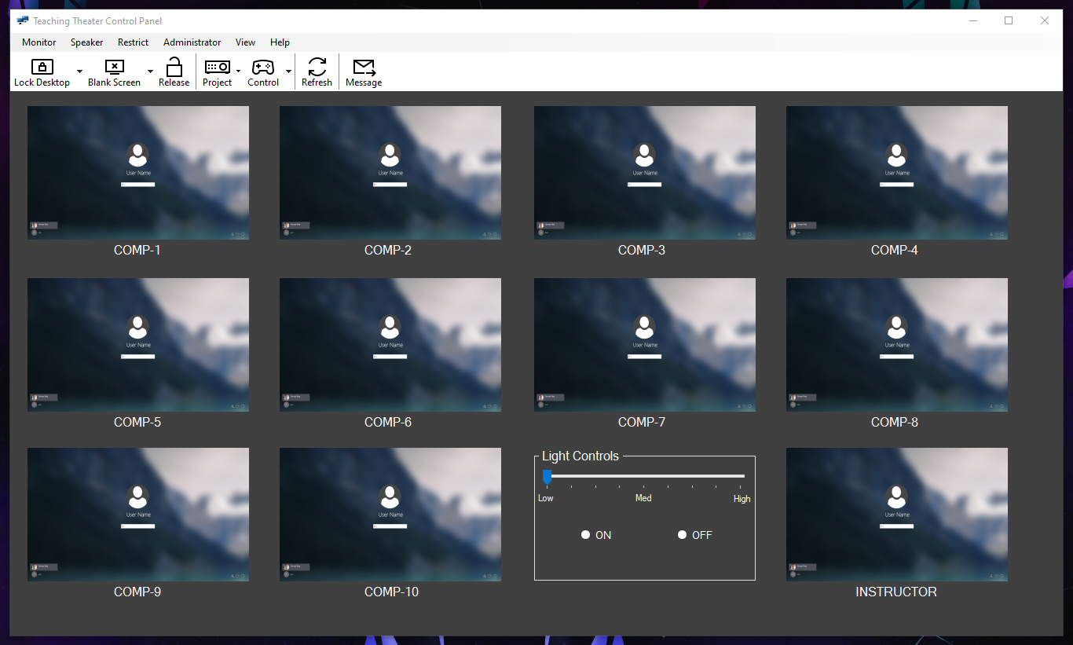

**Part 2: Justify your design based on the guidelines, principles and theories in Chapter 2 (20 points).**

The design I decided to go with is very straightforward, so it’s good for first-time users through expert users. Utilized a very straightforward menu selection interaction style. Design follows/can follow the Eight Golden Rules: consistent, universally usable, feedback-driven, closure dialogs, error-handling, action reversing, user-friendly control, and reduces the amount of short-term memory a user has to utilize. The menu topics are also organized (Taxonomy) to make it easier to find what one is looking for. Grammar and spelling are all correct and easy to follow.

**Question 2: Name a piece of software you often use where it is easy to produce an error. Explain ways you could improve the interface to better prevent errors (15 points).**

A piece of software I use frequently that easily produces an error is the iOS text messaging app. When I am typing a word in, and misspell it, the autocorrect feature occasionally tries to change it to something completely unrelated. The way to improve this would be to either turn autocorrect off, or make the interface not think as abstract as it does when it’s generating possible outcomes for what the user meant.

**Question 3: Give a brief explanation of the Eight Golden Rules of Interface Design. State an example you have seen on a device, computer interface or web site that violates those rules (15 points).**

The Eight Golden Rules of Interface Design guide interface designers in creating consistent, universally usable, feedback-driven, closure dialogs, error-handling, action reversing, user-friendly control, and reduce the amount of short-term memory a user has to utilize. An example of an interface that I have seen violate some of the Golden Rules is the Xbox console dashboard. The Xbox dashboard has gone through at least 7 different iterations, all of these iterations have drastically changed the look and feel of the user system except for the last 3. These last 3 have been fairly similar in design just the aesthetics and scrolling have changed a bit.